**​​1DV503 Database Technology and Modeling**

**Your Name and Surname**

School of Computer Science, Physics

and Mathematics, Linnaeus University, Sweden

[your.email@address.com](mailto:your.email@address.com)

**Task 1 SQL queries using MySQL Workbench DBMS**

| **Query 1** | Find the names of all employees who are working on the project “Computerization”  *Your answer here, for example:*  **SQL:**  SELECT *  FROM Table  WHERE attribute_name='Computerization';  **Result:** |
| --- | --- |
| **Query 2** | **……** |
|  | **……** |
|  | **………** |

**Task 2 Functional Dependencies**

Task 2.1 Solution

Primary key:....

| Functional Dependency | Explanation/Example |
| --- | --- |
| *Your answer here, for example:*  {attribute1} →{attribute2,attribute3,..}  … | …. |

**2.2 Solution**

Primary key:

Functional dependencies:

* {attribute1} →{attribute2,attribute3,..}
* {attribute1} →{attribute2,attribute3,..}
* …..

| *Anomaly* | *Justification/Explanation* |
| --- | --- |
| Redundancy |  |
| Update |  |
| Deletion |  |
| Insertion |  |

**Task 3 Normalization**

**3.1 Solution**

Final tables/relationships all in the 3NF form:

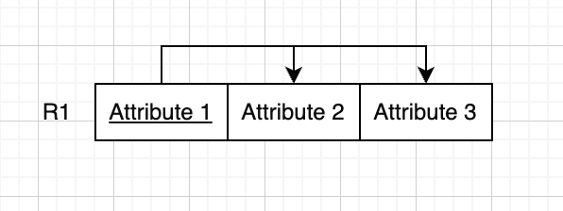

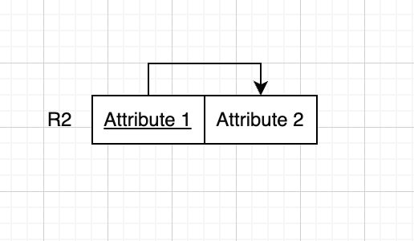

**3.2 Solution**

| **Explanation** | **Result** |
| --- | --- |
| Based on the given primary key, is this relation in 1NF, 2ND, or 3NF?  *Your answer here:* | Diagram before normalization: |
| *Your explanation here….* | Intermediate step diagram, if any: |
| *Finale results* | The final diagrams all tables in 3NF: |